Guided Practice - Ifs Ands Or Elses Lab Report
Use this template to document your work as you complete your assignment.

Your Information
Your Name: Daryl Hymel
Assignment Title: Ifs Ands Or Elses
GitHub Repository: https://github.com/darhym6254/SDC260-Web-Dev-Class

Development Summary
Briefly summarize the work you completed for this guided practice. Include how JavaScript is used to update the page based on user selections.
I finished the City Library portal by connecting the JavaScript, building the navigation, and adding the form options. When the user makes their choices and clicks the button, JavaScript checks the form and displays the correct benefits and resource access without reloading the page. I also fixed the stylesheet link because the original file name was wrong, which was keeping the page from displaying correctly.

Code Explanation
- Explain how JavaScript retrieves information from the dropdown menu and radio buttons.
The dropdown uses getElementById() to find the membership selection and .value to read what was chosen. The radio buttons use querySelector() to find the checked option in each group and return either "yes" or "no".

- Explain how the switch statement determines the membership benefits message.
The switch statement checks the membership choice and matches it to the correct message. The break stops it from continuing into the other cases. Then JavaScript uses textContent to display that message on the page.

- Explain how && and || logic works in a conditional statement.
&& means both conditions must be true, while || means only one condition has to be true. Parentheses help keep related conditions together. I also learned that if and else if statements run from top to bottom and stop at the first true condition, so the order matters.

- Describe the new conditional statement you created for Step 9 and explain when it displays.
I added a condition for students with a regular Member account so they can get interlibrary loans and research database access. I placed it lower in the if/else if chain so it would not override the educator conditions that were already working.

Code Evidence
Insert screenshots that show the completed code for this assignment. Make sure your screenshots are legible and contain the computer system date and time.

Screenshot 1: Completed HTML code
Paste your screenshot below this line:
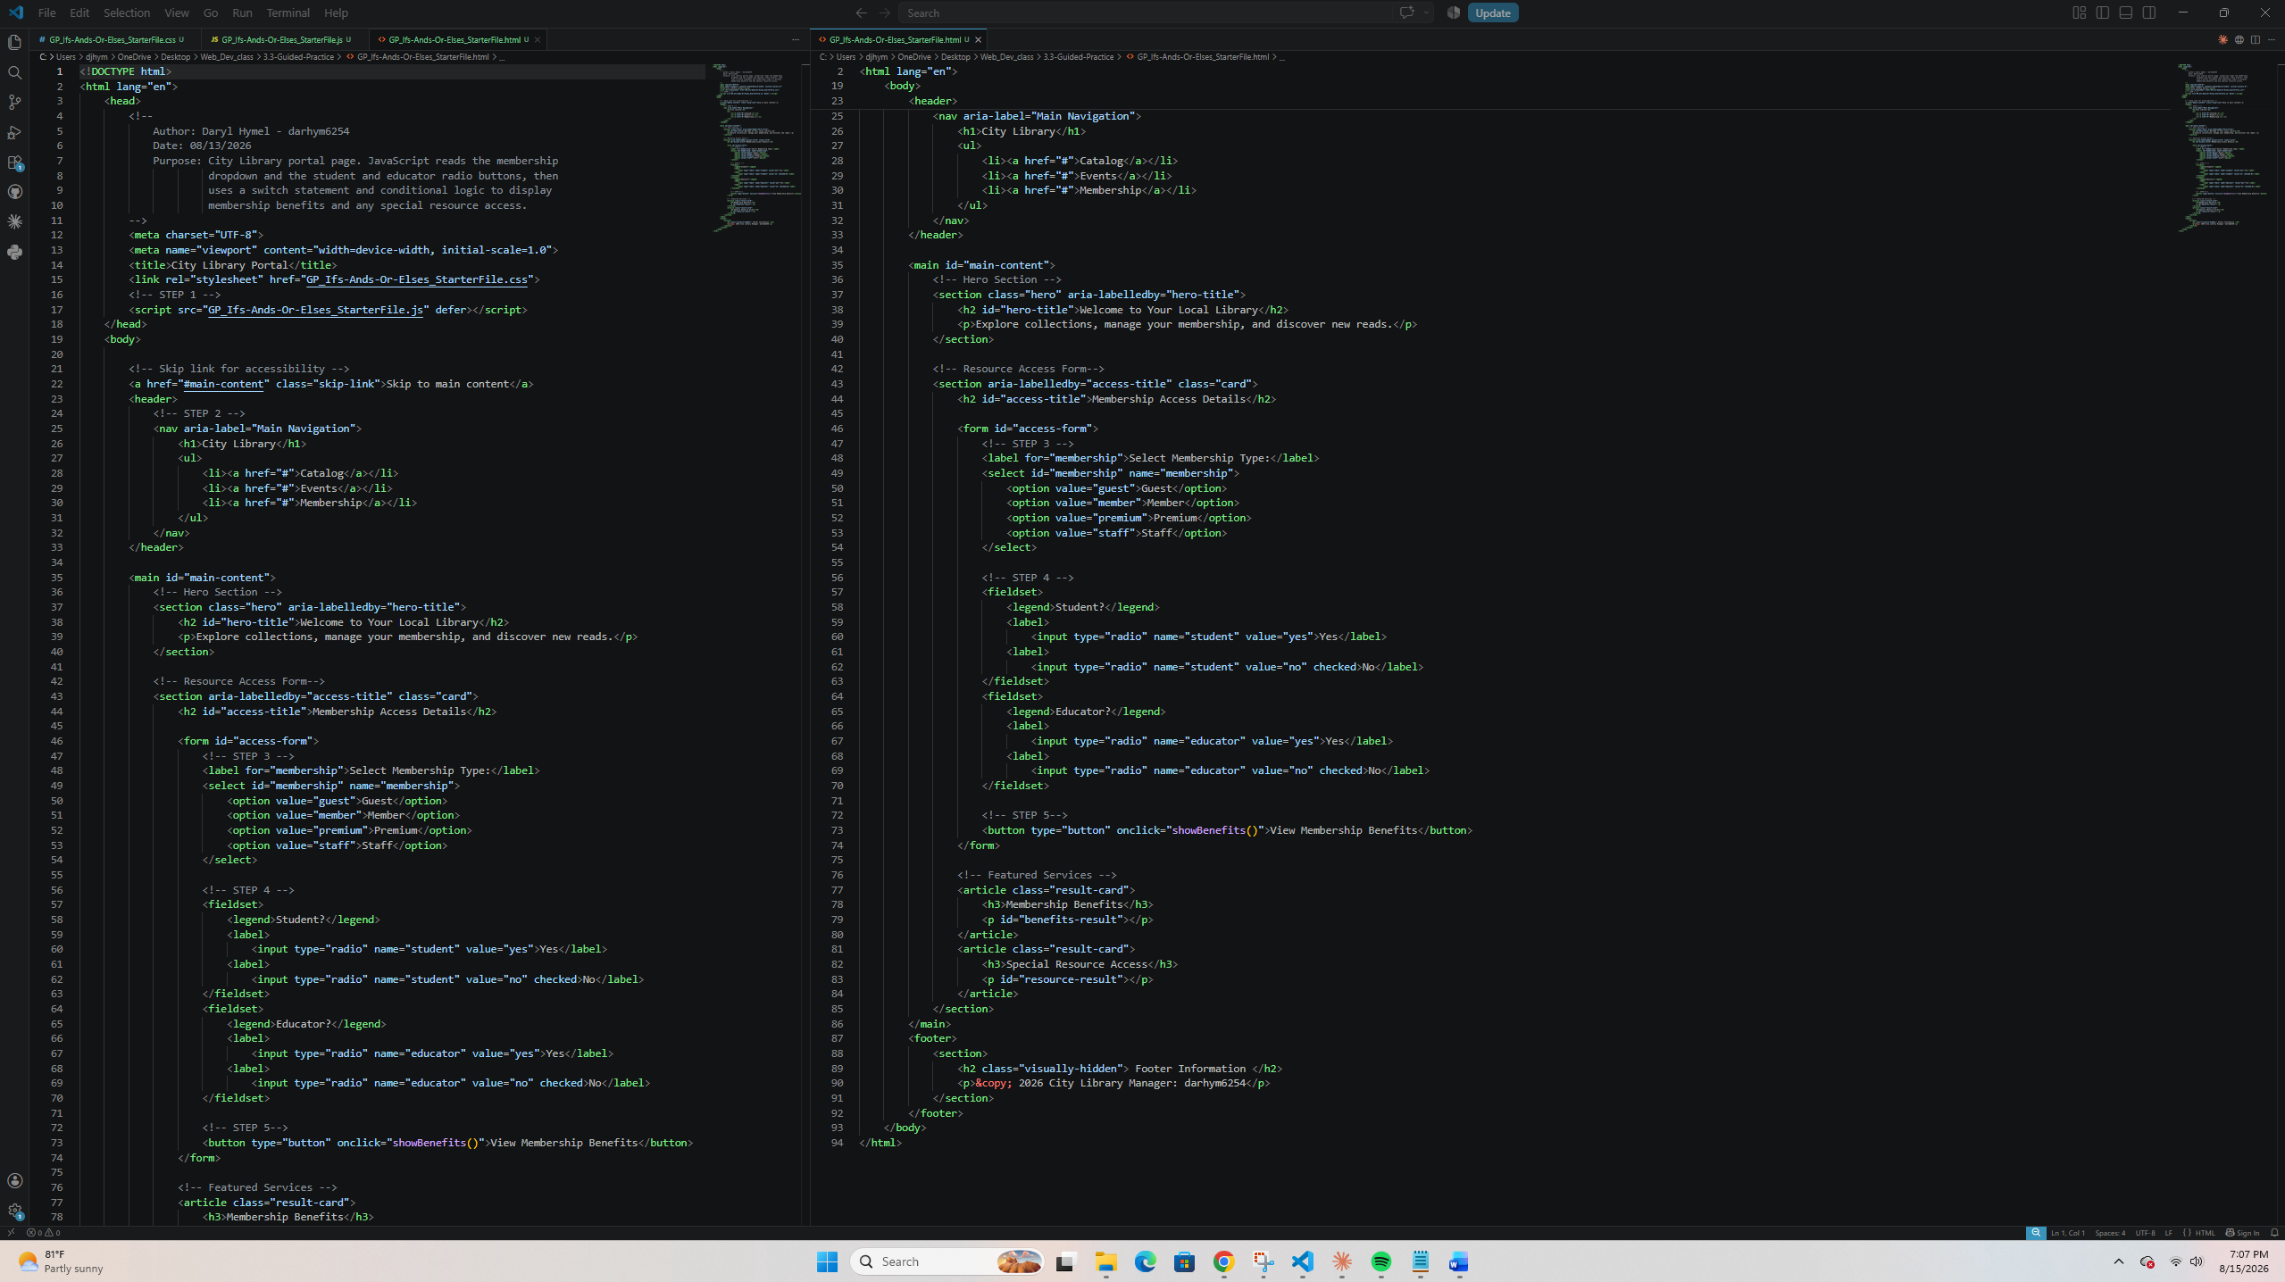

Screenshot 2: Completed JavaScript Code
Paste your screenshot below this line:
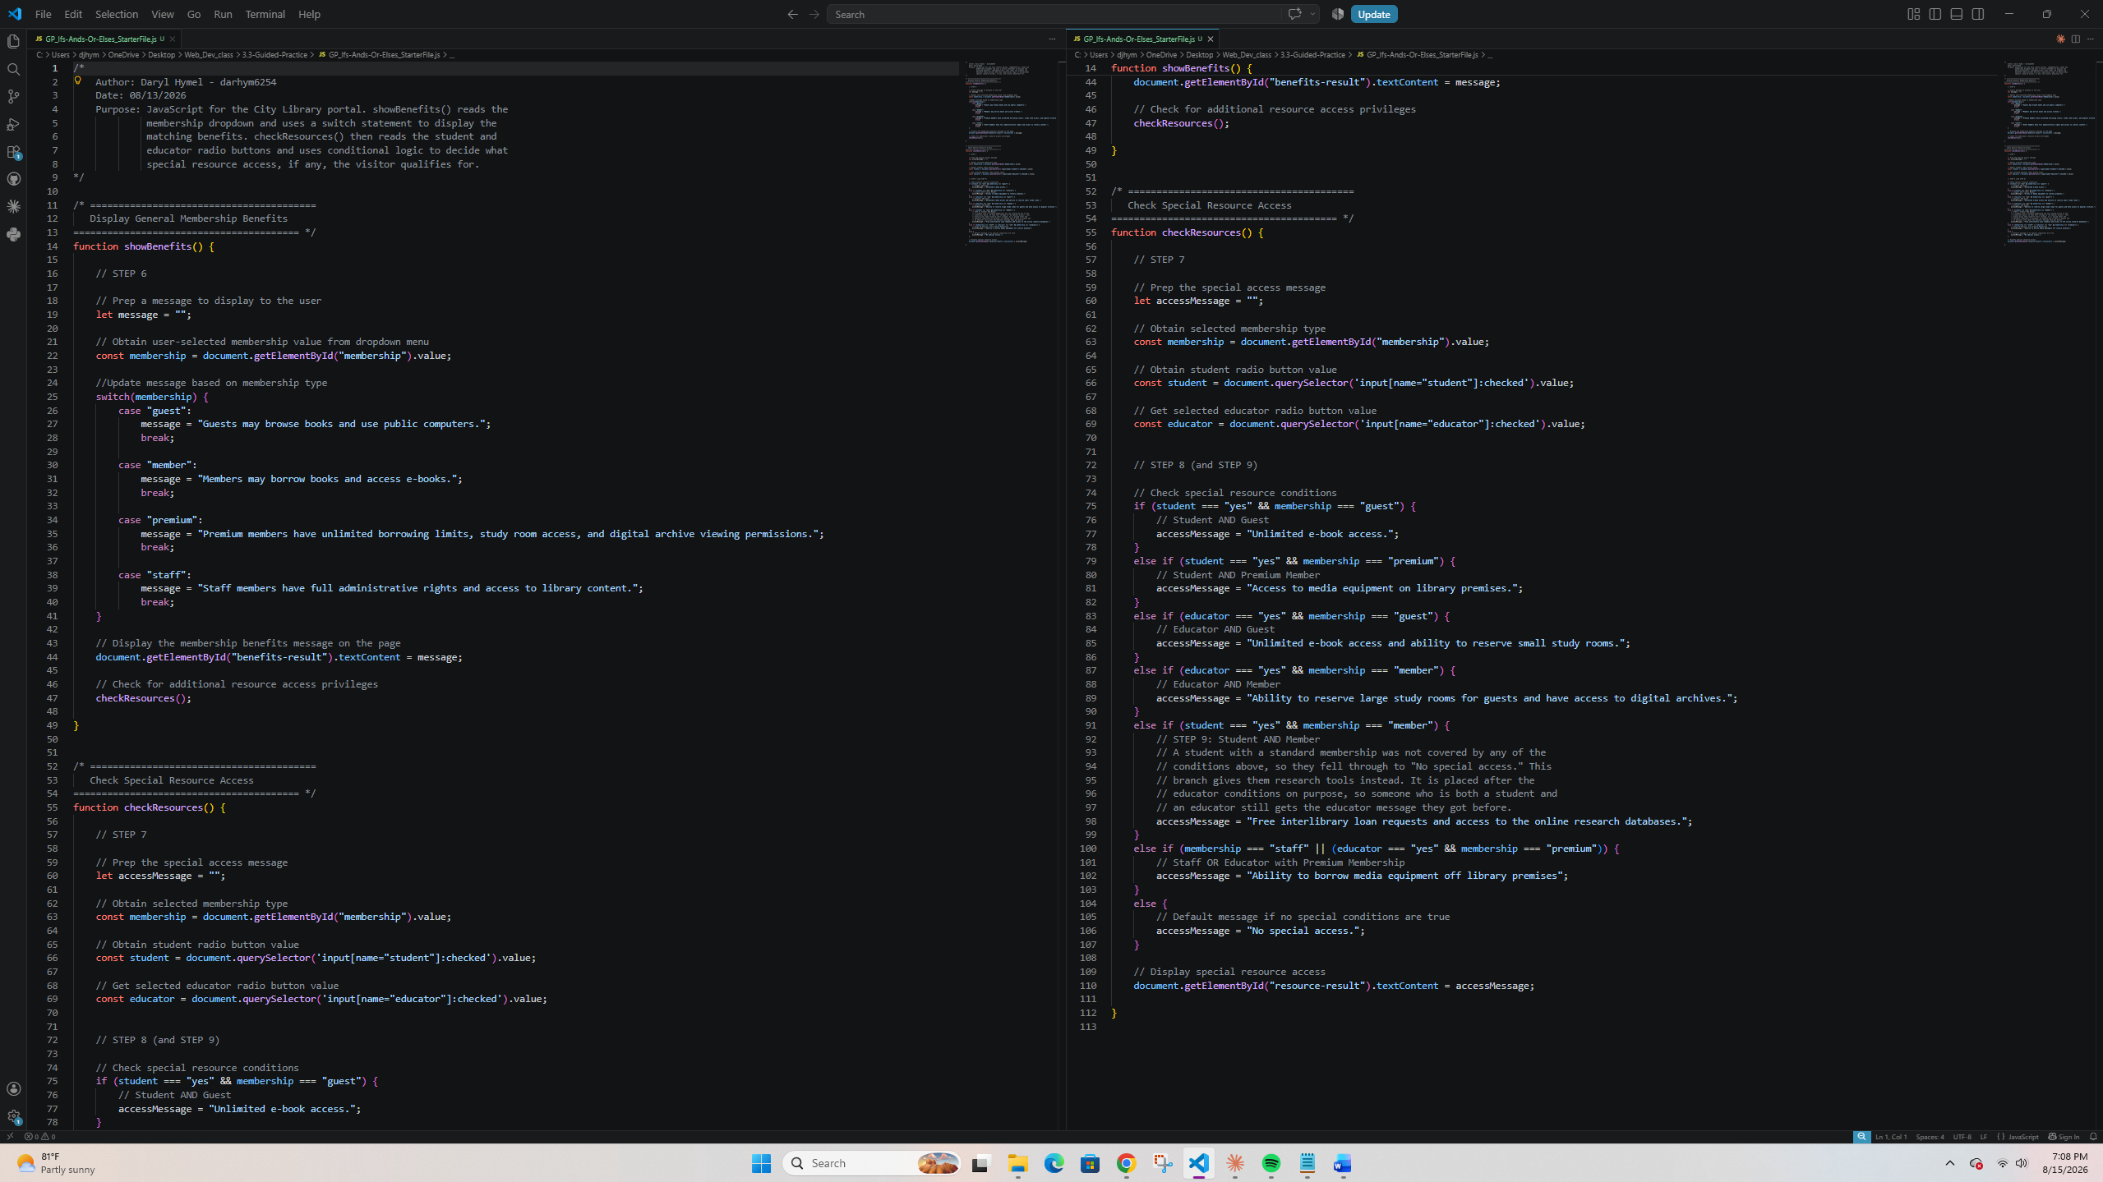

Screenshot 3: Rendered Webpage
Paste your screenshot below this line:
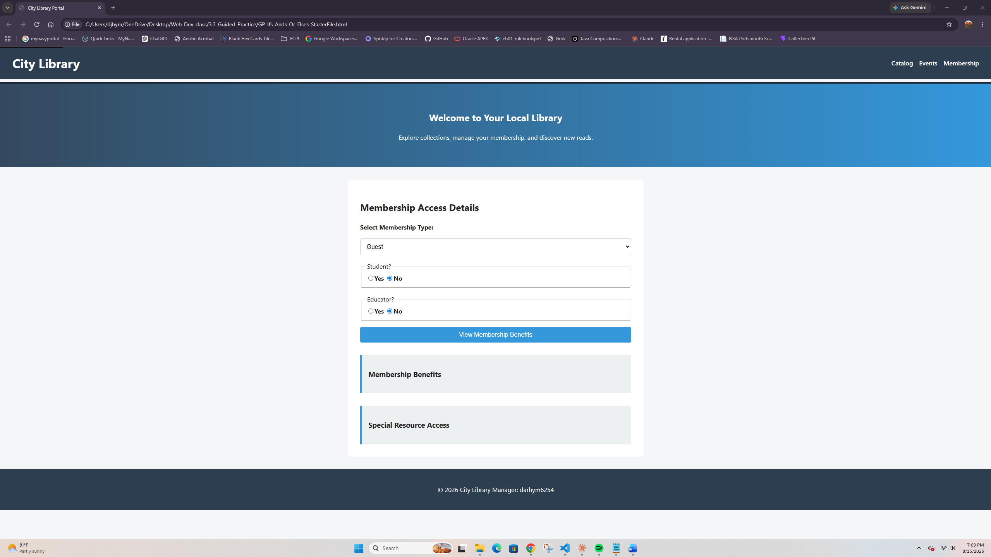

Screenshot 4: Testing Evidence
Paste your screenshot below this line showing special resource access:
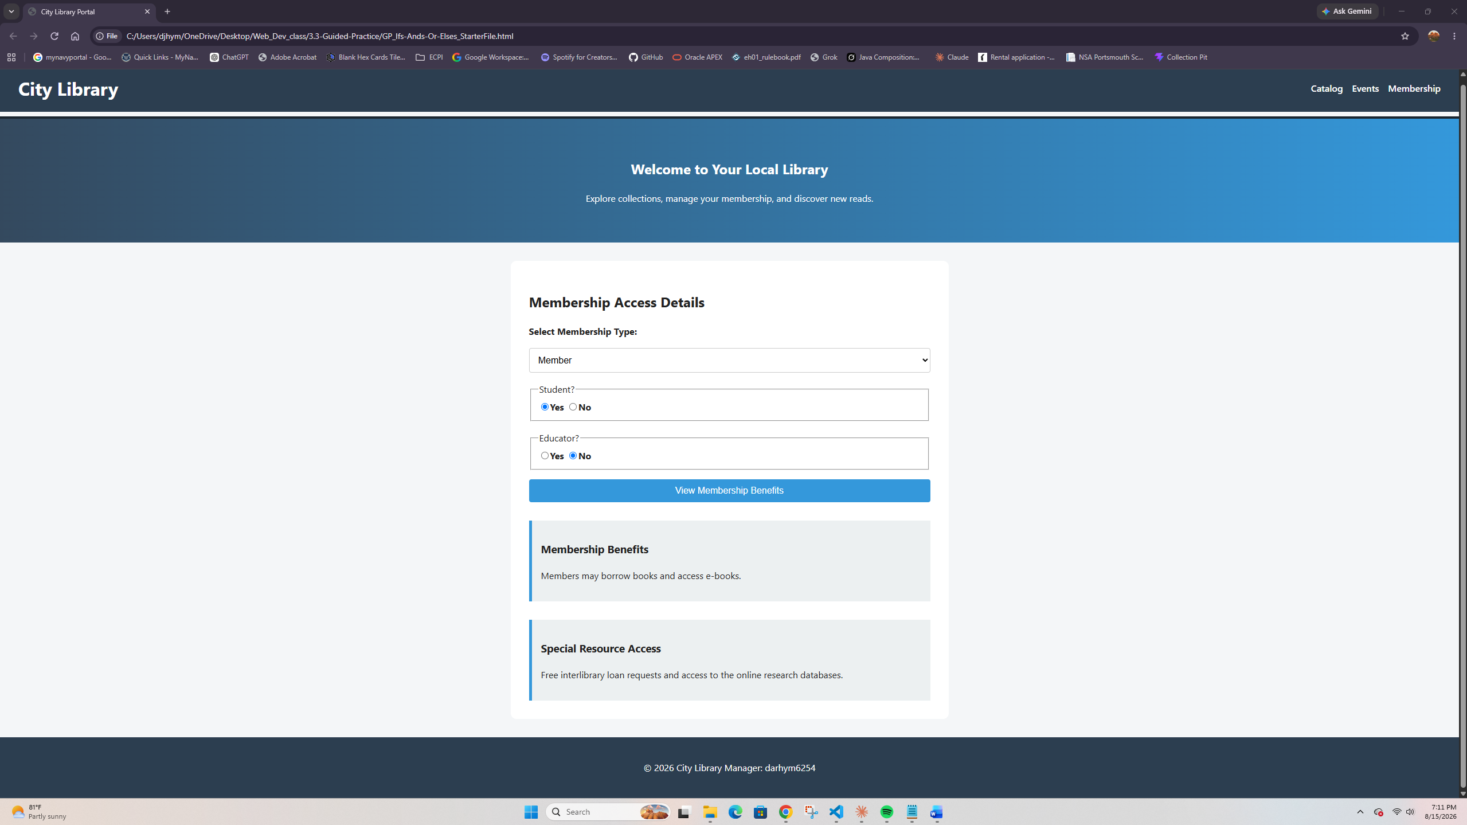

Reflection
- What part of the JavaScript logic was easiest for you to understand?
The switch statement was the easiest part because each dropdown option has its own case and message. It was simpler to read than using a long if and else if chain.

- What part of the conditional logic or DOM interaction was most challenging?
The hardest part was working with the radio buttons because I had to use querySelector and :checked to find the selected option. I also had to test the conditions carefully because their order could change which message was shown.

- How can accessible form design improve the user experience on membership pages?
The page uses labels, fieldsets, and legends to make the form easier to use and understand, especially with a screen reader. It also includes a skip link and an aria-label for navigation. These accessibility features are important because users need to clearly understand the form to get the correct membership benefits.

